Boom Gate & Street Lamp IoT System for Small-scale Enterprises with Blynk Integration

Information of Technology, Stamford International University
Term 1/2025
ITE233: Introduction to Internet of Things
Lecturer: Atikom Srivallop
Date of Submission:
October 6, 2025

Phoo Pyaw Thaw (2310240001)
Ei Thinzar Naing (2310060002)
Cholthicha Khanijomdi (2306280009)

Contents
Abstract 2
Introduction 3
Feasibility Study 3
Analysis & Design 5
Hardware Components 5
Software Tools 5
Logical Design of the System 6
Physical Design of the System (Connections) 8
Structured Chart of the Program 10
Main Program Functions: 10
Implementation (Coding & Blynk) 15
Additional Blynk Details 35
Summary 37
Problems Encountered 37
Overcome Challenges 37
Scope for Further Research 38
1. Additional Sensors and Peripherals 38
2. Sensor Anomaly Detection (Predictive Maintenance) 39
Additional Comments 39
References 41

Abstract

This project proposes an ESP32 IoT-based Toll Gate system for automating gate control, vehicle detection, and streetlights. The system consists of some components like an ultrasonic sensor for vehicle detection, a servo motor for gate control, and LEDs for traffic and streetlights. The system is remotely monitored and controlled using the Blynk mobile app with real-time status and notifications.
Key objectives of the project include improving traffic management, safety, and effective street lighting control. Vehicle counts are also logged by the system for traffic analysis. Issues with hardware compatibility, tuning of sensors, and coding defects were encountered and mitigated. Additional improvement could include additional integration of sensors, predictive maintenance, and user-friendly interfaces to enhance automation, reliability, and usability.

Introduction

Traffic regulation at small-scale toll booths or checkpoints is typically manual, which is time-consuming and prone to human error. An ESP32 Toll Gate IoT system provides vehicle detection automation, gate control, and streetlight control automation.
The system utilizes an ultrasonic sensor to detect approaching vehicles, a servo motor to modify gate motion, and LEDs to show traffic lights and control streetlamps. It is controlled remotely and can be viewed in real-time through the Blynk smartphone app, allowing visual monitoring of system status and information.
The system is aimed at improving traffic flow, enhancing safety, and reducing the rate of manual operation. It also provides a foundation for integrating additional IoT components to enable smart traffic management and automation.

Feasibility Study
Technical Feasibility
The project utilizes universal and stable modules such as ESP32, servo motor, ultrasonic sensor, LEDs, and the Blynk IoT platform. These are universal and may be programmed using Arduino IDE using well-documented libraries. The system design is straightforward and does not require special hardware. Internet communication using Wi Fi is achievable through ESP32. Technical risks are low since each component has been tested in other projects.
Economic Viability
The cost of ESP32, ultrasonic sensor, LEDs, servo motor, and wires is low compared to commercial toll gate systems. The use of the Blynk platform eliminates the cost of building a custom server infrastructure that would be costly. Maintenance costs are low because components can be easily replaced. The project is therefore cheap for educational and small-scale applications.

Operational Feasibility
The system is easy to operate. Streetlights can be toggled from the Blynk app and the gate opens automatically when a car is detected and approved. The interface is clear and requires little training. Data such as distance and car count can be monitored in real time. Operationally it reduces manual work and provides a simple solution for managing small gates or controlled access points.
Schedule Feasibility
The system can be developed and deployed within a short time frame. Programming is straightforward and does not require long development cycles. Hardware setup is minimal and can be completed in a few weeks. Testing and adjustments are also simple since components are modular.
Project Timeline:
Week | Task
1 | Brainstorming and Component procurement
2 | Wiring Setup, Prototype assembly and coding
3 | System testing, Blynk integration, gate calibration

Analysis & Design

Hardware Components
Component | Quantity | Price | Purpose
LED  (1 Red, 1 Green, 2 White) | 4 | 8 | Traffic Light Indication & Street Lamps
Ultrasonic Sensor  (HC-SRO4) | 1 | 65 | Detect Car
ESP32 | 1 | - | Main Control Unit
Servo Motor  (SG90) | 1 | - | Move Boom Gate
BreadBoard | 1 | 60 | Platform to connect components
Jumper Wire  M to M | 40 | 60 | Connect Components
Jumper Wire  M to F | 40 | 60 | Connect Components
Jumper Wire  F to F | 40 | 60 | Connect Components
Resistor | 4 | 4 | Protect LEDs from exploding

Total Estimation: 700 to 800

Software Tools
Software | Purpose
Arduino IDE | Coding, Compiling, and uploading code to ESP32
Blynk Application | Remote control and monitoring data

Logical Design of the System
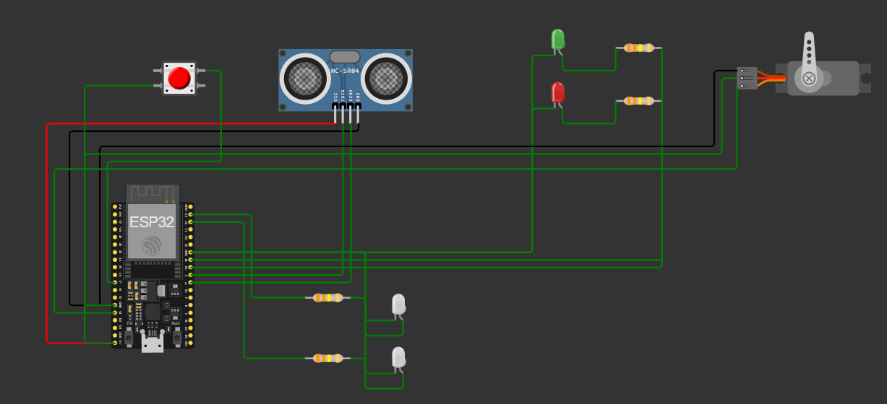

Features / System | Objective | Components | Logical Flow
Car Detection | Detect vehicles approaching the boom gate | HC-SR04 ultrasonic sensor, ESP32, Blynk | Continuously measure distance. If car is closer than 10 cm, send detection signal and notify guard via Blynk.
Boom Gate Control | Open and close gate for authorized vehicles | SG90 servo motor, ESP32, Blynk, LEDs | When guard presses Blynk “Open” button, servo rotates to raise gate. Green LED turns ON. After 5 seconds, gate closes, and Red LED turns ON.
Traffic Light Indicators | Show gate status to drivers | 1 Red LED, 1 Green LED, ESP32 | Red LED indicates gate closed; Green LED indicates gate open. Controlled automatically with gate state.
Street Light Control | Provide illumination at night for safety | 2 White LEDs, ESP32, Blynk Switch | Guard can toggle streetlights remotely via Blynk app. State is logged to chart for ON/OFF history.
Manual Override | Allow guard to bypass automatic system | Blynk virtual button, ESP32 | Guard can press “Emergency Override” button in Blynk app to force gate open regardless of car detection.

Physical Design of the System (Connections)
Project Video Drive Link: https://drive.google.com/file/d/1Wv9EiD68xyC7sba1lk3UtbelmndlMWSi/view?usp=sharing

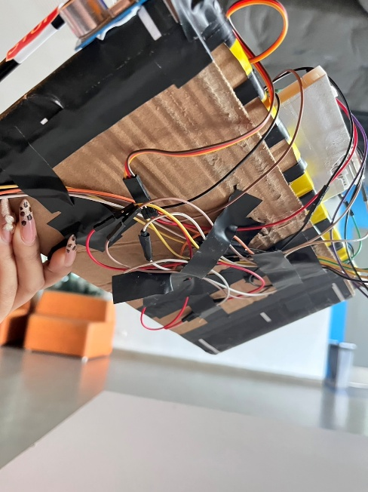
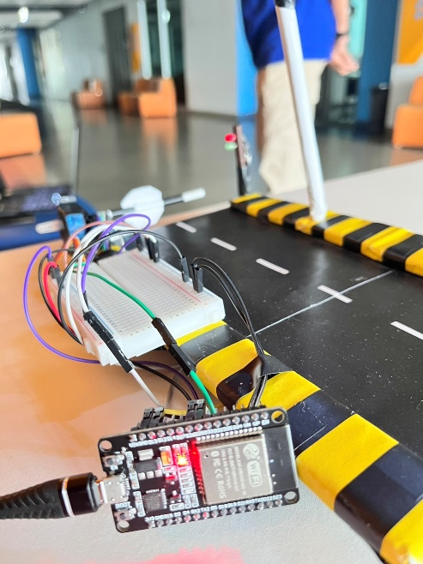
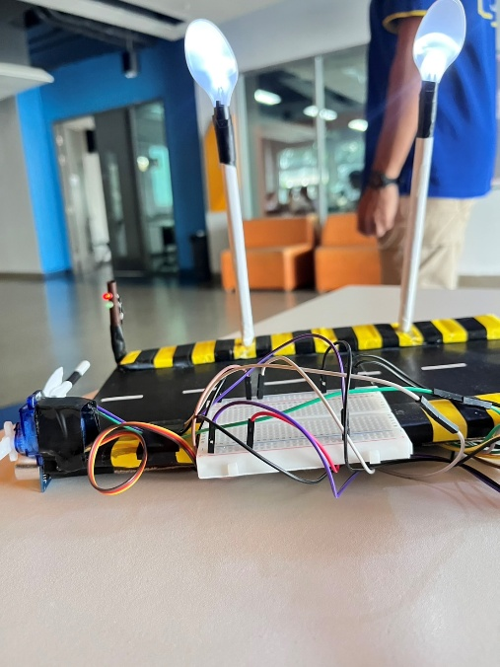
0

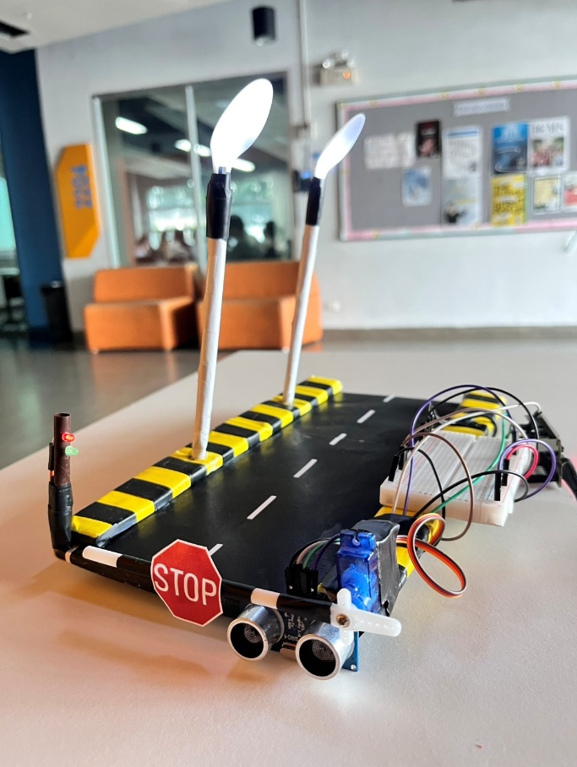

Component | Pin/Connection | ESP32 Pin
Street Light LED 1 | Anode (+) | GPIO 23
Street Light LED 2 | Anode (+) | GPIO 22
Street Light LEDs | Cathode (-) | GND
Traffic Light Red LED | Anode (+) | GPIO 19
Traffic Light Green LED | Anode (+) | GPIO 18
Traffic Light LEDs | Cathode (-) | GND
Servo Motor (Gate) Signal | Signal | GPIO 13
Servo Motor (Gate) Power | VCC | 3.3V
Servo Motor (Gate) Ground | GND | GND
Ultrasonic Sensor VCC | VCC | 3.3V
Ultrasonic Sensor Trigger | Trigger | GPIO 26
Ultrasonic Sensor Echo | Echo | GPIO 25
Ultrasonic Sensor GND | GND | GND
Power Supply Positive | 3.3V | 3.3V
Power Supply Negative | GND | GND

Structured Chart of the Program
The program starts by initializing the ESP32, sensors, LEDs, servo motor, and Wi-Fi/Blynk application for remote monitoring and control.
It then enters a continuous loop to monitor sensor readings and user input:
- If the ultrasonic sensor detects a car, the system notifies the guard via Blynk.
- If the guard presses the “Allow” virtual button, the boom gate opens (servo moves, green LED ON, red LED OFF).
- After set time, the gate closes automatically, and LEDs revert to their default state.
- The LDR continuously monitors light levels. At night, when a car passes, the streetlamps automatically turn ON; they switch OFF when no car is present.
- The program continuously updates the status label in Blynk for monitoring by the guard.
System events (car detected, gate opened/closed, lamp ON/OFF) are logged via Serial Monitor for debugging and reference.

Main Program Functions:
Function | Detailed Explanation
Initialize Components | Set up ESP32 pins, configure ultrasonic sensor, servo motor, LEDs (red, green, streetlamps), and LDR. Initialize Wi-Fi connection and start the Blynk application for remote monitoring.
Car Detection | Continuously monitor the ultrasonic sensor. If a car is detected within 10 cm, trigger a notification in Blynk (“Car waiting for approval”). Set system state to waiting for guard approval.
Gate Control (Servo + LEDs) | When the guard presses the “Allow” button in Blynk, activate the servo to lift the boom gate, switch the LED from red → green, and update the status label. After 5 seconds, the servo closes the gate and LEDs revert (green OFF, red ON).
Traffic Light Indicators | Manage red/green LEDs to signal drivers. Red = stop (gate closed), Green = go (gate open). LEDs automatically update based on gate state.
Streetlamp Automation | Continuously monitor the LDR. If light levels are low and a car passes, automatically turn ON both streetlamps (white LEDs). Lamps turn OFF when car leaves or light level rises.
Manual Override (Blynk Virtual Button) | Guard can press “Allow” button in Blynk regardless of automatic detection, opening the gate manually. Useful in case of sensor error or emergency.
Monitoring and Logging | Print all system events to the Serial Monitor (e.g., “Car detected”, “Gate opened”, “Street lamps ON”) for debugging, performance evaluation, and system reliability checks.

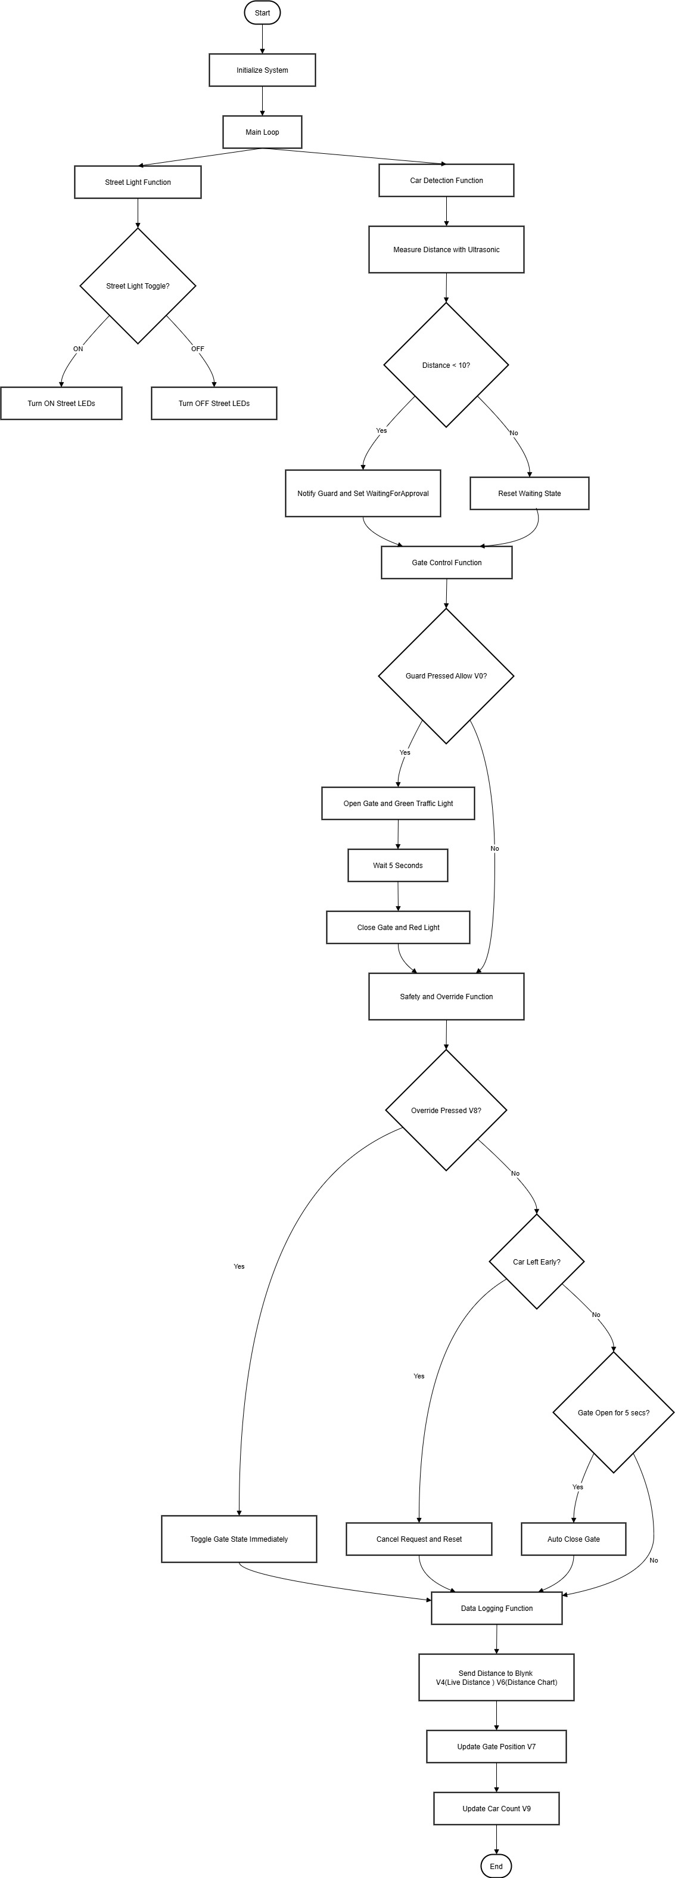

Implementation (Coding & Blynk)
1. Arduino Code
Firstly, to connect to the Blynk Platform, we defined the unique Blynk template ID, Name, and authentication token
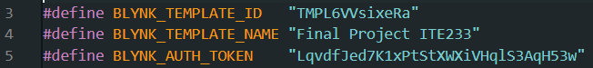
The included libraries enable network connectivity <WiFi.h>, Blynk functionality <BlynkSimpleEsp32.h>, and control of the servo motor <ESP32Servo.h>.
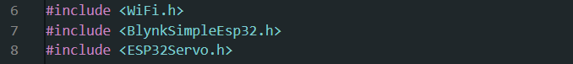
Libraries | Role | Usage
WiFi.h | Connects the ESP32 to your Wi-Fi network so it can communicate with the Blynk app for remote monitoring and control. | Ensures that the guard can receive notifications like “Car waiting for approval” and control the gate via the app.
BlynkSimpleEsp.h | Allows the ESP32 to interface with the Blynk mobile app | - Send notifications when a car is detected.  - Updates the gate status label and LEDs in the app.  - Reads virtual button presses from the guard to open/close the gate manually.
ESP32Servo.h | Controls the servo motor that operates the boom gate. | - Opens the gate when a car is approved.  - Close the gate automatically after a delay.  - Works together with red/green LEDs to indicate gate status.

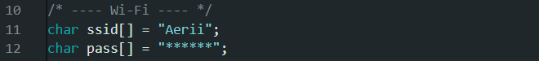
We provided the network login details. The ESP32 uses this SSID and password to join the local Wi-Fi network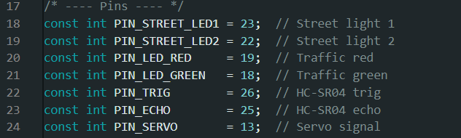
We assigned the physical wires to the code. The const int declarations define GPIO pin numbers for the output devices (Street Lights, Red/Green Traffic LEDs, HC-SR04 Trig pin, Servo signal) and the input pin (HC-SR04 Echo pin). This makes the rest of the code cleaner and easier to read.

DIST_THRESHOLD_CM is the threshold distance. We set that the system would only consider a car as "present" if the ultrasonic sensor could detect an object within 10 cm of it.
OPEN_HOLD_CM initiates the auto-close timer. After the gate is opened, it is programmed to close automatically after 5 seconds (5000 milliseconds) so that a vehicle will have enough time to move through before the gate will close. 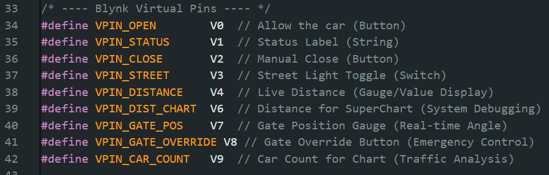
We mapped the project's functions to the Blynk App interface by assigning virtual pins.

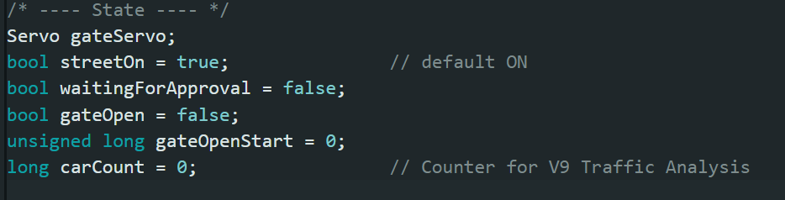
Then we set the system’s current or default conditions and variables
- gateOpen: Is the barrier up or down?

- waitingForApproval: Has a car been detected but is awaiting permission?

- streetOn: Are the streetlights currently lit?

- carCount: How many vehicles have passed (for logging)?

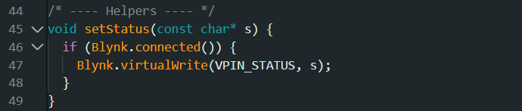
To display a text status message to the V1 Status Label widget on Blynk dashboard
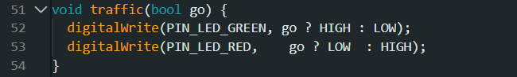
The traffic() function is responsible for controlling the two traffic light LEDs (Red and Green) to provide visual indication of the toll gate status.
•If go is true (Allowed Passage): The system sets the Green LED (PIN_LED_GREEN) HIGH (ON) and the Red LED (PIN_LED_RED) LOW (OFF). This signal is set right before the servo moves to the open position (goOpen()).
• If go is False (Blocked Passage): The system turns ON Red LED HIGH and OFF Green LED. It stays the same when the gate is closed (goClose()) or waiting for operator’s acknowledgment.
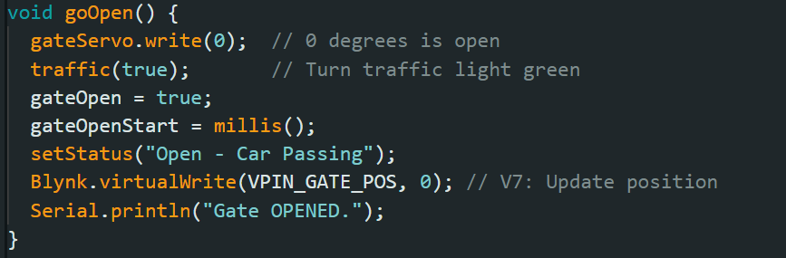
The goOpen() function is responsible for executing all the actions necessary: mechanical, visual, timing, and communications, to be capable of opening the toll gate from a waiting, closed position to a passing, open position. It is typically called after the operator has pressed the "Allow" button on the Blynk application.
- Move Gate: Directs the servo motor to the 0-degree position (gateServo.write(0)) and opens the toll gate.
- Signal Passage: Activates traffic(true) to toggle the traffic lights, illuminating the Green LED and turning off the Red LED.
- Update State: Updates the system flag gateOpen = true.
- Start Timer: Records the current time (gateOpenStart = millis()), initiating the 5 second auto-close timer.
- Notify Operator: Displays the status message "Open - Car Passing" to the Blynk mobile app via setStatus().
- Update Blynk: Servo Position (V7)
- Log Event: Prints "Gate OPENED." to the Serial Monitor for local observation and debugging.
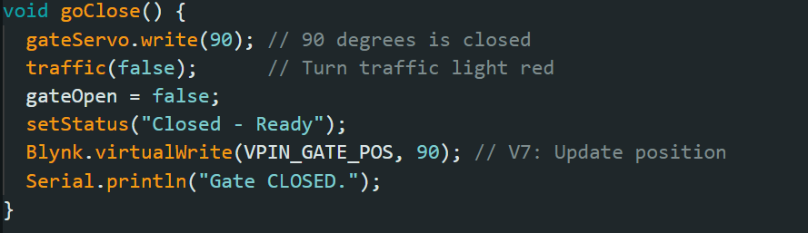
The goClose() function does it all: mechanical, visual, and communications, to close and lock the toll gate successfully from an open, passing state to a ready-to-detect, secure state. Automatically by the 5 second timer within the loop () or manually through the operator, it is typically called.
- Move Gate: Moves the servo motor to the 90-degree position (gateServo.write(90)), physically closing and locking the toll gate.
- Signal Stop: Calls traffic(false) to alternate the traffic lights, making the Red LED ON and the Green LED OFF.
- Reset State: Assigns the system flag gateOpen = false; to indicate that the gate is closed and locked currently.
- Update Status: Sends the status message "Closed - Ready" to the Blynk mobile app through setStatus().
- Update Blynk: Servo Position (V7)
- Log Event: Prints "Gate CLOSED." to the Serial Monitor for local monitoring and debugging.
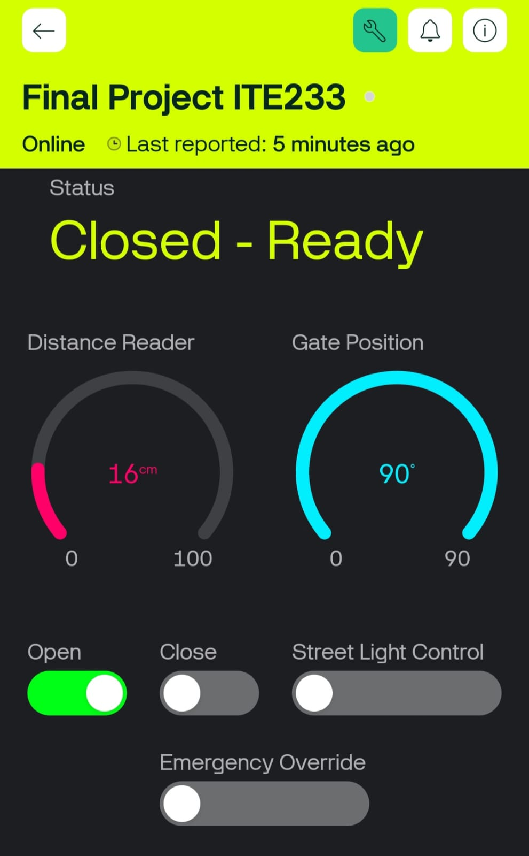

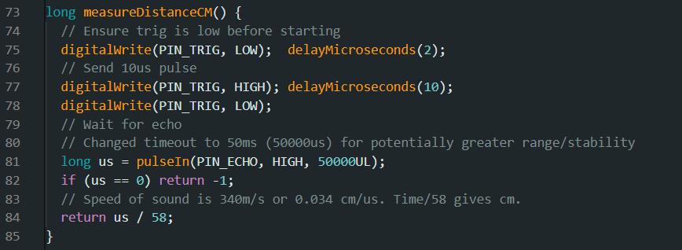
The measureDistanceCM() function is the Ultrasonic Sensing Routine responsible for continuously scanning the toll gate area to detect the presence and proximity of a vehicle. It does so by implementing the default protocol for the HC-SR04 sensor: emitting an ultrasonic pulse and measuring the Time of Flight (TOF) of the echo to calculate the distance in centimeters.
- Pulse Initiation: The function first sets the trigger pin clear and then generates a 10 microsecond HIGH pulse on the PIN_TRIG, which tells the sensor to emit an ultrasonic sound wave.
- Time Measurement: It uses the pulseIn() function to measure how long (in microseconds, us) the echo pin (PIN_ECHO) is HIGH, which is how long the sound took to travel out and back. It allows a generous 50 ms timeout for stability.

- Error Handling: If the pulseIn() command times out (i.e., returns 0), then this implies no echo was ever received (object too far or reading failed), and the function returns −1 to signal an invalid measurement.

- Distance Calculation: The measured time (us) is divided by the constant 58 (which is calculated from the speed of sound, where Distance(cm)= Time(μs)/58

- Data Output: The calculated distance is sent in centimeters by the function to the main loop() function, where it is used for car detection and sent to the Blynk app (V4).

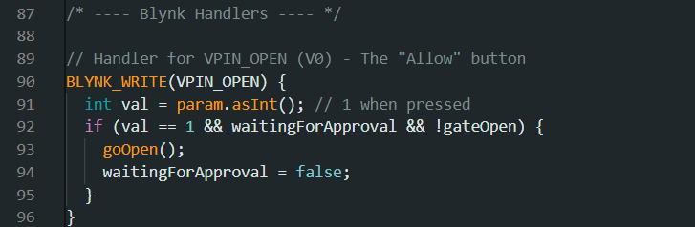
VPIN_OPEN Handler (V0 - "Allow" Button)
This handler executes the command to open the gate, with all necessary safety measures.
- Trigger: Triggers when the operator presses the "Allow" button (V0) on the Blynk app.
- Safety Logic: It invokes goOpen() solely if the button is pressed (val == 1), a car has been detected and is waiting (waitingForApproval is true), AND the gate is not already open (!gateOpen).
- State Reset: goOpen() resets waitingForApproval = false after it is called, which resets the car request.
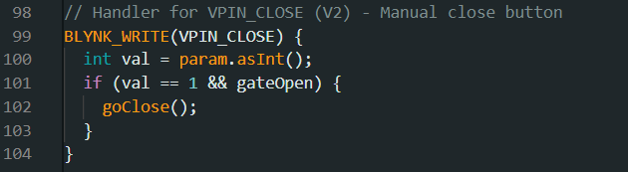

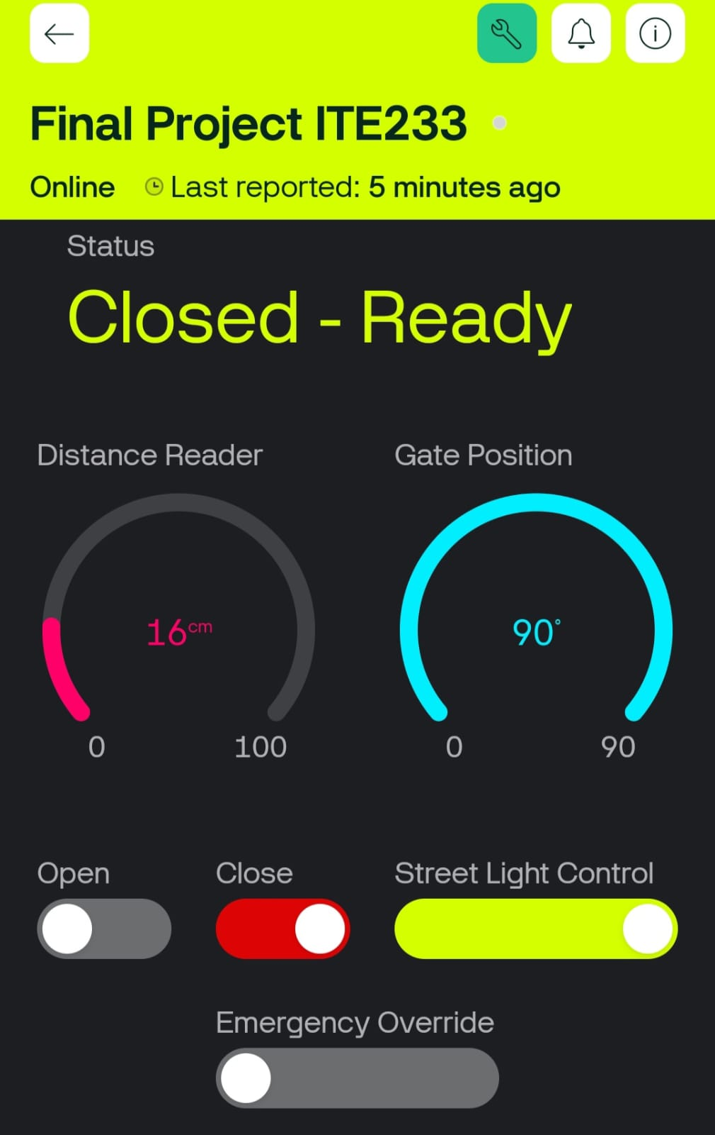
VPIN_CLOSE Handler (V2 - "Manual Close" Button)
This handler provides the operator with an override to close the gate instantly.
- Trigger: Runs whenever the operator presses the "Manual Close" button (V2).
- Condition: It only calls goClose() if the button is pressed (val == 1) AND the gate is open (gateOpen is true).
- Result: The gate closes instantly, overriding the 5 second auto-close timer.
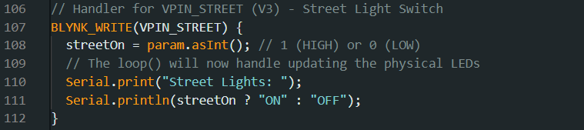
VPIN_STREET Handler (V3 - Street Light Switch)
This handler manages the ON/OFF state of the streetlights based on remote input.
- Trigger: Runs when the Street Light Switch (V3) is toggled within the app.
- State Update: It updates the global variable streetOn based on the switch state (1 for ON, 0 for OFF).
- Execution: The persistent logic within the main loop() function then reads this updated streetOn variable to switch the physical Street Light LEDs ON or OFF.
- Logging: Prints the new state to the Serial Monitor for local diagnostic logging.
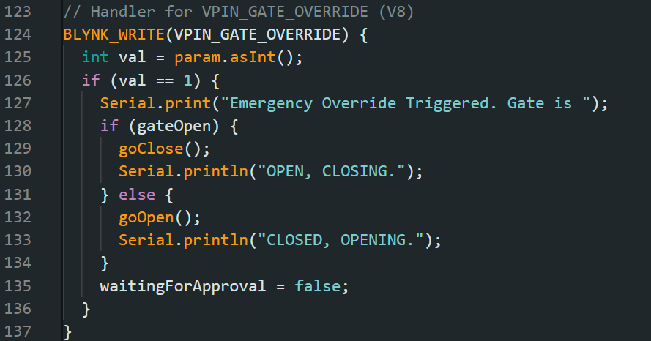
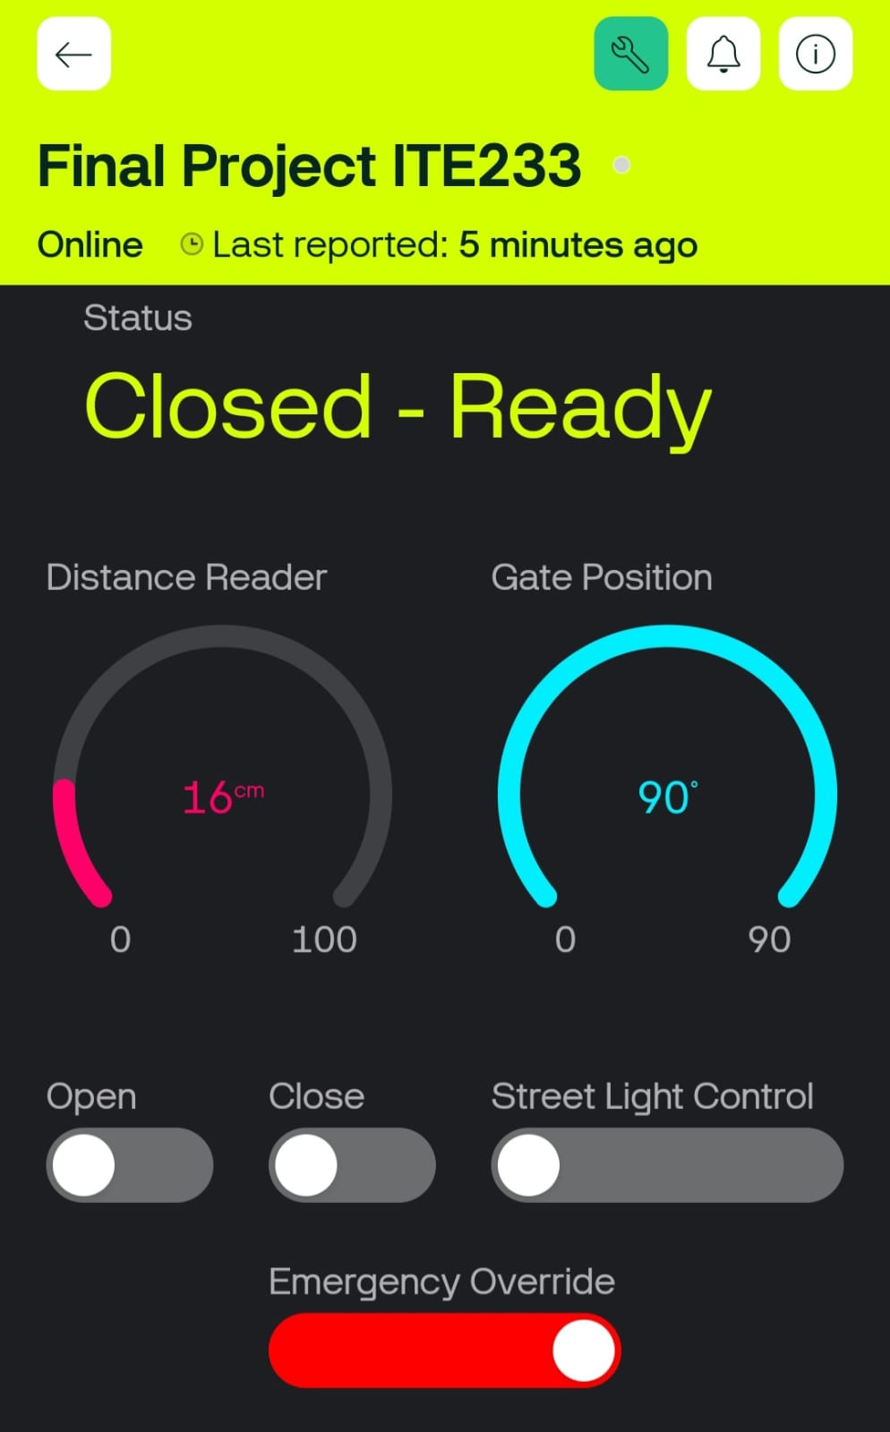

When the override button is pressed (val=1), it flips the current state of the gate: if the gate is
open (gateOpen is true), it calls goClose(); otherwise, it calls goOpen(). Critically, it also sets
waitingForApproval = false to clear any pending car approval request, ensuring the manual
command takes immediate precedence.
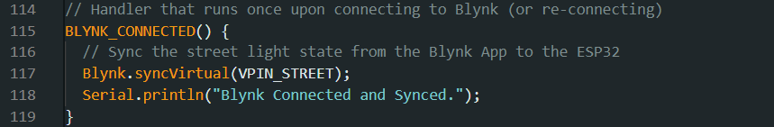
This event handler checks the physical hardware against the application's state at connection.
- Trigger: Runs automatically every time ESP32 reconnects successfully to the Blynk cloud.

- Purpose: The function calls Blynk.syncVirtual(VPIN_STREET), which commands the ESP32 to obtain the current reading of the Street Light Switch (V3) from the cloud.

- Result: This action immediately updates the local streetOn variable so that the physical streetlights (controlled in loop()) show the operator's current setting, precluding state mismatch at startup.

- Logging: Confirms the success of the operation by printing a message to the Serial Monitor.the success of the operation by printing a message to the Serial Monitor.
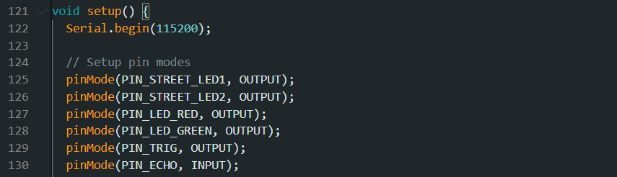
Initializes the Serial Monitor connection at a baud rate of 115200.

Pin Mode Configuration
- pinMode(PIN_STREET_LED1, OUTPUT); (and other LED pins): Sets up the pins where the street lights and traffic light LEDs (Red/Green) are connected to OUTPUT. This allows the ESP32 to supply a voltage (HIGH or LOW) on them to switch the lights ON or OFF.
- pinMode(PIN_TRIG, OUTPUT): Sets up the Trigger pin of the ultrasonic sensor as OUTPUT. This allows the ESP32 to supply the short pulse needed to activate the sound wave.
- pinMode(PIN_ECHO, INPUT): Sets the Echo pin of the ultrasonic sensor as INPUT. This makes it possible for the ESP32 to record the incoming duration of the reflected sound wave (the echo).
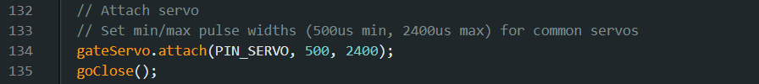
This code starts the servo gate and sets the streetlights' initial power state.
- gateServo.attach(PIN_SERVO, 500, 2400);
Servo Attachment: Binds the servo motor on its defined pin, with calibration parameters (500 µs to 2400 µs) for smooth movement.
- goClose();
Initial Gate Position: Calls the goClose() function immediately, so that the gate will be in the closed position (90 degree with the Red light ON) when booting.
Default Lights: Switches both the streetlights ON (HIGH) as the initial default condition. This
condition will be later adjusted (synchronized) by the Blynk cloud.
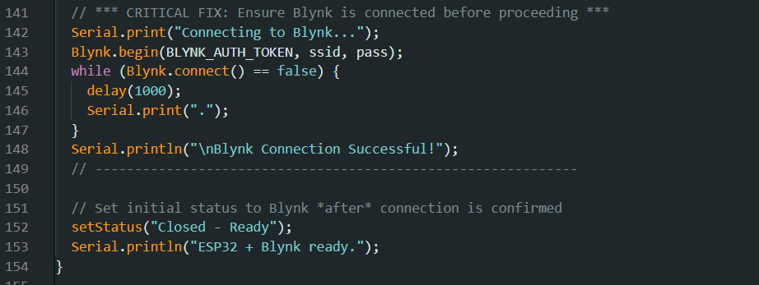
- Serial.println("Connecting to Blynk.");
Used for: To print the startup of trying to connect locally to the Serial Monitor for debugging and testing.
- Blynk.begin(BLYNK_AUTH_TOKEN, ssid, pass);
Used for: To set up the network connection using the stored Wi-Fi credentials and authenticate with the Blynk server. Remote control is enabled.
- while (Blynk.connect() == false) {. }
This is a mandatory waiting loop (our large patch). We added this to prevent the program proceeds until a solid connection has been made. The gate logic cannot function without this connection as it relies on the app for control and status feedback.
- Serial.println("\nBlynk Connection Successful!");
Logging: Also checks internally that the system is now online.
- setStatus("Closed - Ready");
Final Notification: We send the initial system status message to the mobile app only after the connection is checked. This notifies the remote operator that the system is in position and ready to receive a car.
- Serial.println("ESP32 + Blynk ready.");
Final Local Confirmation: signifies that the entire setup process is complete.

void loop()
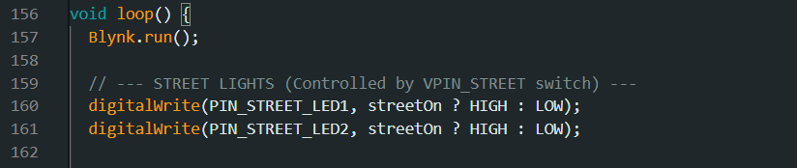
We run the blynk and keep the Wi-Fi connection on
To constantly enforce the ON/OFF state of the physical streetlights based on the operator's remote switch setting.

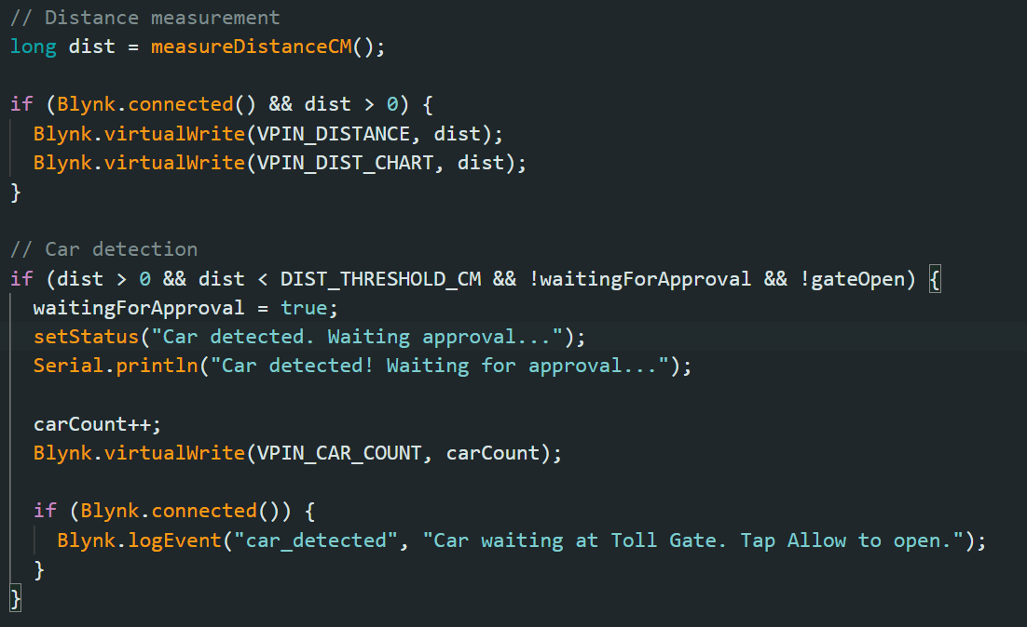

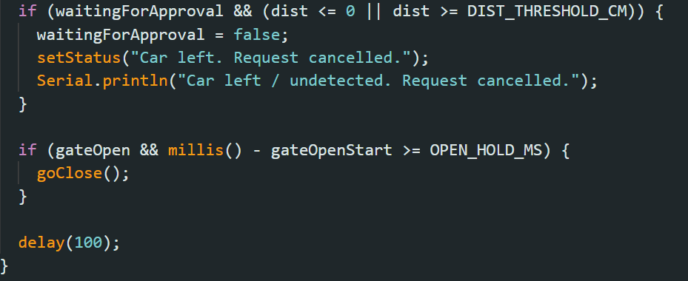

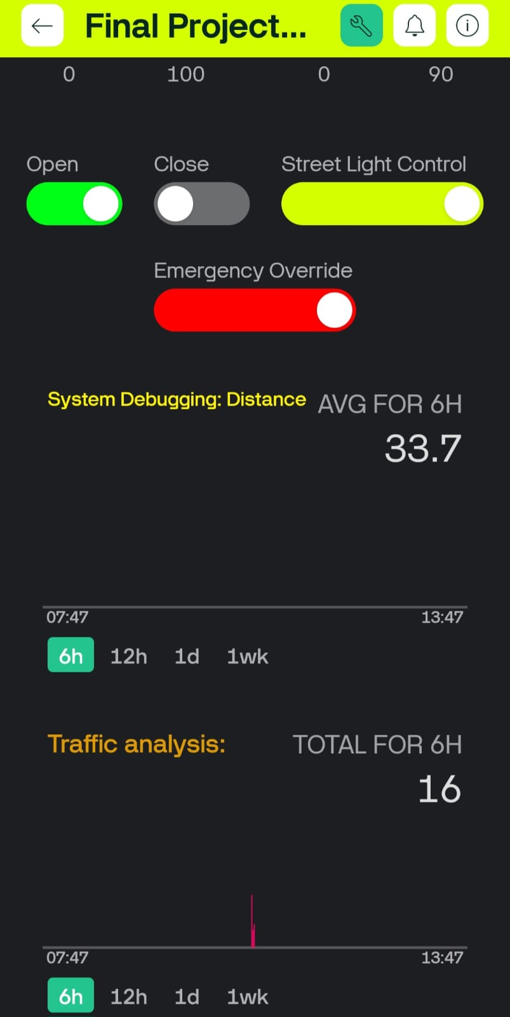
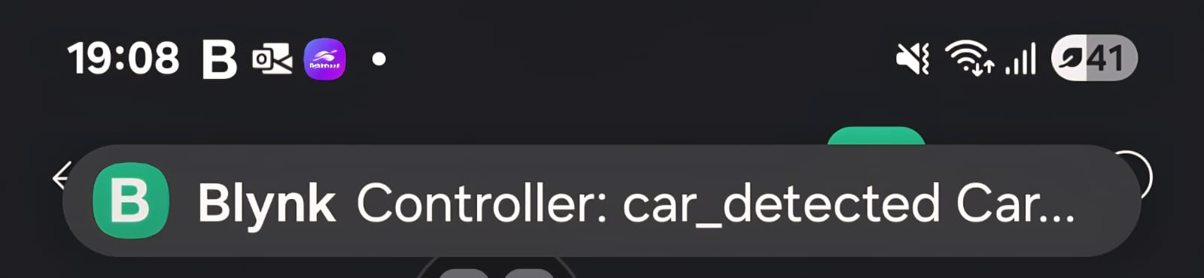
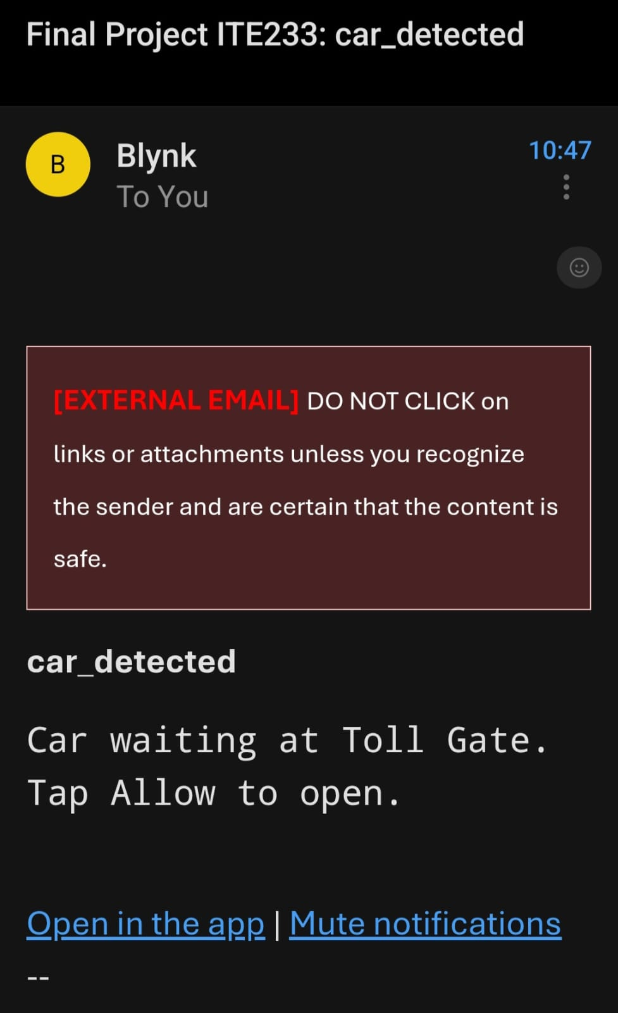

To send the live data from sensors to Distance for guage(V4), Distance Chart(V6), and Car Count Chart(V9). Moreover, update status, log and trigger push notifications, and cancel a waiting request if the car moves away or the sensor loses the reading, resetting the system status.

Additional Blynk Details
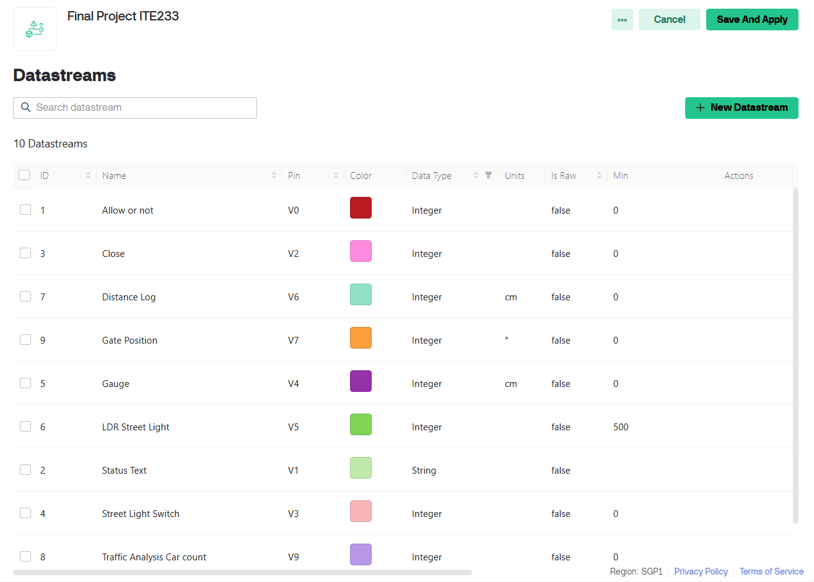

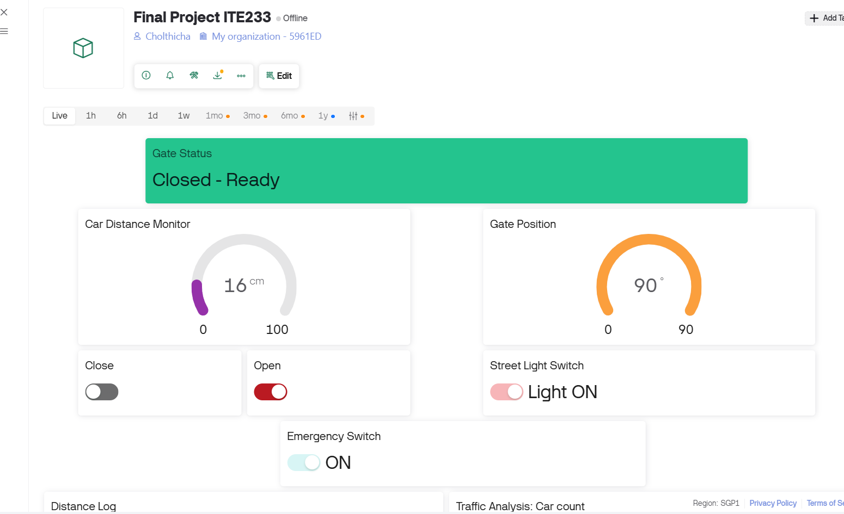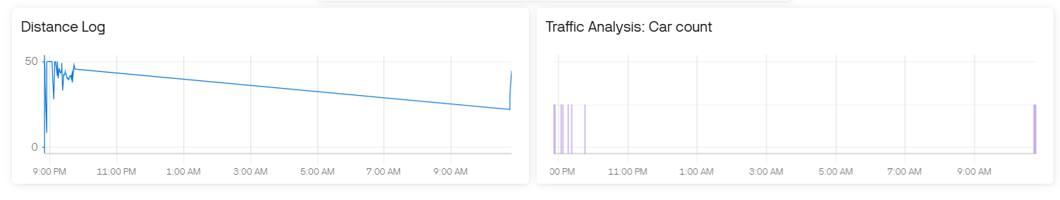

Summary

Throughout the process of creating our ESP32 Toll Gate IoT project, including vehicle detection, gate opening/closing, and street light automation, we realized numerous challenges as well as significant successes.

Problems Encountered
- Board Issue: To begin with, we bought an Uno R3 Wi-Fi + ESP8266 board, which failed to work as expected, likely due to its poor quality. We made use of an ESP32, which was simpler to work with, although we needed to re-write the program to make it compatible with ESP32.
- Coding Errors: Sometimes coding errors such as incorrect assignments to variables led to erratic behavior. Debugging and comprehensive testing fixed such issues.
- Component Issues: The servo motor was technically faulty, and the ultrasonic sensor was wrongly connected and unable to take readings. Once the wire issue was corrected and the components calibrated, everything worked fine.
- Power Supply: Our power cell was 3.7V, but ESP32 requires 3.3V, so we used a laptop or power bank to supply the power instead.

Overcome Challenges
- Programming Problems: Integration of different parts (ultrasonic sensor, servo, LEDs) required careful programming to ensure smooth working. Debugging and testing were also crucial to make sure the system is reliable.
- Integration: Syncing and wiring of parts like the ultrasonic sensor and servo, and LED control, were problems overcome by careful assembly and testing.

Scope for Further Research

1. Additional Sensors and Peripherals
Camera (ESP32-CAM):
Including an ESP32-CAM module can enhance the system by enabling live video streaming and taking photographs. This can prove to be particularly useful to monitor vehicle number plates or capture images for security purposes. In addition, it can also be used to let familiar faces in by integrating machine learning.
LCD Display:
Adding an LCD display can provide real-time data such as gate status, vehicle count entry, and system alerts. This is easy to use and provides immediate feedback without the need for a connected device. Moreover, it can also be used to communicate with the car passenger(s)
LDR (Light Dependent Resistor):
An LDR can be used for controlling streetlights based on the level of surrounding light. This switch lights on during the night and off during the morning, offering maximum energy efficiency.
RFID/NFC Reader (RC522):
Including an RFID/NFC reader facilitates secure entry control. RFID-tagged vehicles can be provided with automatic toll gates, lowering the process of toll gates. RC522 module communicates with ESP32 via SPI and operates at 3.3V.
LiPo Battery with TP4056 Charging Circuit:
Employing a 3.7V LiPo battery and a TP4056 charging module provides a handy portable power solution. TP4056 takes care of charging and over-discharge protection for reliable functioning of the battery.
Voltage Divider for Battery Monitoring:
A voltage divider circuit can be utilized in measuring the voltage level of the battery via an analog pin of the ESP32. The battery status can be monitored in real time, and an alert can be triggered when the battery is low.

2. Sensor Anomaly Detection (Predictive Maintenance)
Predictive maintenance can be achieved through the observation of sensor readings to detect anomalies that would indicate likely failures. By establishing baseline sensor readings for all the sensors, variations from the baseline would be recognized as anomalies. Machine learning techniques can be applied to classify these anomalies and forecast likely failures, allowing for proactive maintenance and reduced downtime.

Additional Comments
Our ESP32 Toll Gate IoT project reflects an actual and innovative way of traffic management and automation. The device incorporates multiple sensors, actuators, and automated controllers, which makes it a reliable tool for managing car entry and streetlights.
Even though the existing system works properly, it can be improved. Installing other sensors like cameras, RFID readers, and LDRs will enable better automation, security, and user interface. The addition of predictive maintenance will enhance reliability and enable better decision-making.
By maximizing the user interface, the system can be made more user-friendly and accessible, suitable for a broad spectrum of applications in real-world settings.
Overall, the project is successful in integrating hardware and software to produce a functional IoT solution, with huge potential for ongoing development into an even more intelligent, secure, and responsive traffic management system.

References

Clarke, A. (2016, August 18). Modify ultrasonic sensors for 3 volts logic (prepare HC-SR04 for ESP8266, ESP32, etc.). Instructables. https://www.instructables.com/Modify-Ultrasonic-Sensors-for-3-Volts-Logic-prepar/

DroneBot Workshop. (2020, February 1). Using servo motors with the ESP32. DroneBot Workshop. https://dronebotworkshop.com/esp32-servo/

Google. (2025). Gemini [Large language model]. Google AI. https://gemini.google.com/

Jayan, J. (2017, July 2). Servo motor controlled with Blynk over WiFi. Instructables. https://www.instructables.com/Servo-Motor-Controlled-With-BLYNK-Over-WiFi/

OpenAI. (2025). ChatGPT [Large language model]. OpenAI. https://chat.openai.com/

Rui, S. (2021, June 17). ESP32 with HC-SR04 ultrasonic sensor with Arduino IDE. Random Nerd Tutorials. https://randomnerdtutorials.com/esp32-hc-sr04-ultrasonic-arduino/

